VISION OF HOPE CHILDREN’S CENTRE UGANDA
CONSTITUTION.

.
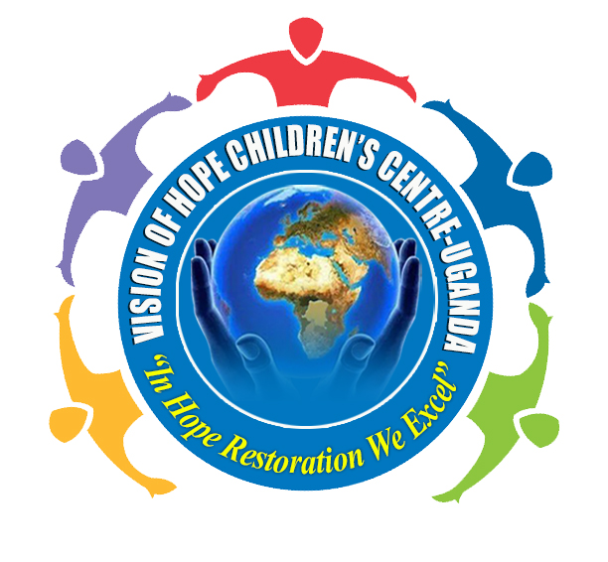

THIS IS THE CONSTITUTION OF VISION OF HOPE CHILDREN’S CENTRE UGANDA AND IT SERVES TO ALL MEMBERS AND CLIENTS.

PREAMBLE

VISION OF HOPE CHILDREN’S CENTRE - UGANDA is a Hope restoration Community based Organization (CBO) in masaka district.
This organization is founded by Tamale Ashiraf after growing as a needy, abandoned child who grew up under the guidance of a single mother. It started in April 2018 with 5 children, 2 boys and 3 girls who were not supported at the first but now supported and registered. We hope to help more children through this program.

The children stay in the program from time of registration up to 20 years if not departed due to contradictions and not complying with the policies.

The program is aiming at developing children and their families in four aspects of life (i.e. Physical, socio-emotional, economic and spiritual).

We hope to help children grow economically by topping their school fees in different schools where they go. They are equipped with livelihood skill through HOPE SKILLS PROJECT like handcraft skills for example bags, bangles, necklaces and many more.
Also some of our children have received hens through THE HENS OF HOPE PROJECT as a way of training our children how to rare hens and we monitor this project throughout all stages.

The Socio –emotional aspect is tackled in a way that children are taught how to relate well with others and how to deal with their emotions at all times of life.

The physically part children are to be treated when sick and are also taught how to live healthy, care givers who are HIV positive are to be encouraged to take their medication and counseled at all times.

Spiritually, children, their families and the community shall be exposed to the love and redeeming gospel of Jesus Christ.

ARTICLE 1: NAME OF THE ORGANISATION.
The organization shall be called VISION OF HOPE CHILDREN’S CENTRE UGANDA.

ARTICLE 2: LOCATION OF THE ORGANISATION
The organization shall be located in Masaka district, Ssenyenge ‘B’.

ARTICLE 3: AREA OF OPERATION.
This organization is a non-profitable community based organization.
We shall register children around Kimaanya A and B, Kisuuna, Ssenyange and Masaka town.
The child registered in this program should be staying in the nearby places to the Centre site.
ARTICLE 4: VISION AND MISSION STATEMENT
- VISION
The vision of this organization is seeing a changed generation full of hope

- MISSION STATEMENT:
We seek to be a channel of hope to the helpless children, by expressing the love of God to them, making a warm environment to restore hope and producing young responsible citizens.

ARTICLE 5: AIMS AND OBJECTIVES
- To produce psychosocial therapy with in self-help group and self-reliant skills.
- To provide formal education/vocational skills training to children.
- To build capacities of poor, vulnerable families to be able to respond to socio-economic challenges.
- Advocating for a supporting policy frame work that leads improvement of the lives of the vulnerable population.
- To restore hope to the hopeless in a local community.
- To feed the needy children and transforming them into a required person to grow the community.

ARTICLE 6: CORE VALUES AND ACTIVITY LINE-UP.
- CORE VALUES.
- Loving every person for excellence.
- Restoring hope in the lives of the African needy child.
- Being responsible citizen in the community.
- Respect and Equality to all people.
- Making a warm environment to the hopeless children.
- Being a mother to the motherless and a father to the fatherless.

- ACTIVITY LINE-UP.
- Child mentorship, counseling and guidance.
- Capacity building and advocacy.
- HIV/AIDS guidance and prevention.
- Primary health education (hygiene and nutrition).
- Child protection to the community and to the guardians.
- Co-curricular activities to children.
- Children shall always come for Centre days once in a month (every last Saturday).
- Care givers/parents shall always attend a monthly meeting where they shall be taught child protection and child development.
- Parents are requested to pay 5000/- per term only(15000/- only per year) to facilitate the local organization activities.
- There shall be home visits and school visit to every child once a year.
- Every child is entitled on having a fire at the Centre for record keeping.
ARTICLE 7: MEMBERSHIP.
Membership shall constitute children who maybe total orphans, partial orphans, and other highly vulnerable children. The parents shall also be members by virtue of his or her child being a member in the organization.

SECTION A: Selection criteria
Membership qualifications.
1. Total orphans and partial orphans who are needy shall be given priority.
2. Children shall be between 2 years to 6 years old.
3. The distance from the Centre to the child’s home shall not exceed 4km so that the child is able to come for Centre activities whenever he/she is needed.
4. Not more than 2 children shall be registered unless the family is in a very bad state and this does not go beyond two children.
5. Children who have both parents who are unable to meet the basic needs of the children shall also be registered. (Highly vulnerable children)
6. There shall not be any segregation of children based on denominational back ground or Sero-status.
7. Children sponsored by other donor agencies shall not be registered.
SECTION B: MEMBERSHIP FEE AND SUBCSRIPTION.
- Children shall be registered at free fee and each child member shall subscribe 15000/- yearly as long as he/she is still a member.

ARTICLE 8: MANAGEMENT STRUCTURE
SECTION A:
The management structure shall be led by the vision bearer/overseer followed by the board of directors, followed by the volunteer helper (executive committee members), followed by parents and children.

Over seer/vision bearer

Board of directors

Voluntary helpers (executive committee members)

Parents & children

SECTION B: BOARD MEMBER ROLES.
- OVERSEER.
This is a leader and founder that shall chair the organization committee and shall lead the organization together with the committee.
- BOARD OF DIRECTORS.
This committee shall elect different committees in the organization which shall be responsible for different associations of the organization.
- VOLUNTARY HELPERS.
This shall be made by two child development officers. These shall be employed staffs responsible for monitoring and supervising the day today running of the activities of the organization.
These shall work hand in hand with the board of directors.
- PARENTS AND CHILDREN.
These are the guardians for the children, they stay with the children, since the children are not take from their families.
Parents shall be having a parental committee and it will be led by one of the parents.
SECTION B: QUALIFICATION OF THE EXECUTIVE COMMITTEE MEMBER.

1. Every selected member shall be a committed born again Christian with a good testimony in the community.
2. Selected persons shall be people who are accessible.
3. The members shall be able to read and write in at least a local language.
4. The members shall be persons who are faithful, available and teachable.
5 person who are not married but with the qualifications shall be selected as leaders and to the marrieds should be having a monogamous marital status.
6. Shall not be one who seeks self-interests but works to satisfy God and his creation.
7. Members of the same family shall not be selected both to be board members.
8. They shall agree to serve voluntarily for a period of not more than 3 years.
9. The overseer shall be an ex-official of the committee.
10. The overseer shall take the responsibility of convening the meetings for the selection of such members.

ARTICLE 9: FINANCES
All funds used must be countable for and always with receipts.
SECTION A: SOURCES OF REVENUE.
The organization’s main source of funding shall be:
1. Funds sent from donor from different parts of the world.
2. Funds collected locally from organization projects.
3. Networking with other funding agencies. Any project funds shall be collected and banked on the organization bank account.
4. Funds collected from the care givers (15,000/= yearly).
NB; the organization shall have a bank account. The account is to have 3 signatories selected from the board of directors led by the overseer.
These will sign to prove cheques for the organization and all transactions.

SECTION B AUDITING
1. There will be an auditor to pass through and balance organization account books.
2. Once in a while there shall be external auditors.
ARTICLE 10: AMENDMENTS.
- Any article in this constitution shall be amended by board of directors meeting that shall be called upon when there is a need.
- Any amendment shall be done with not less than 70% of the total committee members.

ARTICLE 11: DISSOLUTION.
The organization shall not close when there is political instability that can interfere with efficient service delivery.
NAME, RESPONSIBILITY AND CONTACT OF THE COMMITTEE MEMBERS

Name | Contact | Responsibility | Signature
TAMALE ASHIRAF
PR. TUSHABE FREDRICK
NAMATOVU AGNES KISAAKYE
NALUGOTI VICENCIA

END.

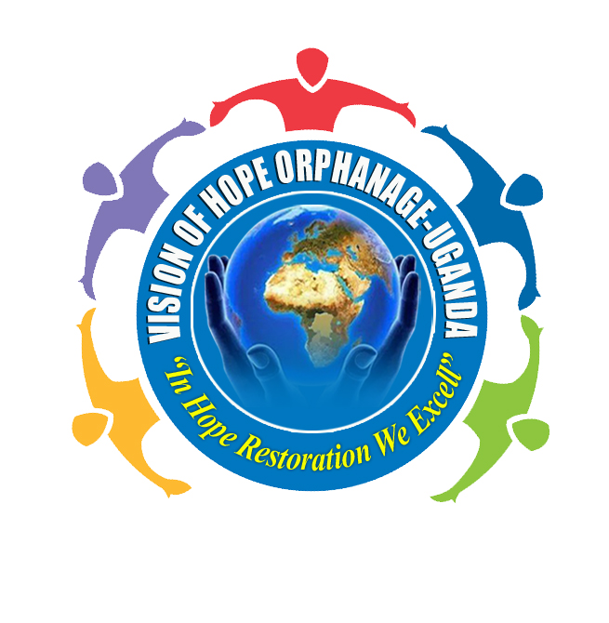
VISION OF HOPE CHILDREN’S CENTRE UGANDA
“In Hope restoration we excel’’
Tel: +256 704544517/ +256 779726269
cvisionofhope@gmail.com
Location: Masaka Uganda
P.O. Box ……………., Masaka

cvisionofhope@gmail.com
Masaka-Uganda
East-Africa

