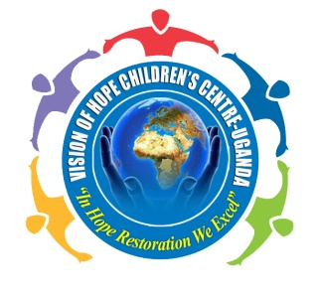
VISION OF HOPE CHILDREN’S CENTRE UGANDA
“In Hope restoration we excel’’
Tel: 0704544517/ 0779726269
cvisionofhope@gmail.com
Masaka Uganda
P.O. Box ………………, Masaka

VISION AND MISSION STATEMENT.
- MISSION STATEMENT:
We seek to be a channel of hope to the helpless children, by expressing the love of god to them, making a warm environment to restore hope and producing young responsible citizens.

- VISION
The vision of this organization is seeing a changed generation full of hope

AIMS AND OBJECTIVES
- To produce psychosocial therapy with in self-help group and self-reliant skills.
- To provide formal education/vocational skills training to children.
- To build capacities of poor, vulnerable families to be able to respond to socio-economic challenges.
- Advocating for a supporting policy frame work that leads improvement of the lives of the vulnerable population.
- To restore hope to the hopeless in a local community.
- To feed the needy children and transforming them into a required person to grow the community.

CORE VALUES AND ACTIVITY LINE-UP.
- CORE VALUES.
- Loving every person for excellence.
- Restoring hope in the lives of the African needy child.
- Being responsible citizen in the community.
- Respect and Equality to all people.
- Making a warm environment to the hopeless children.
- Being a mother to the motherless and a father to the fatherless.
- ACTIVITY LINE-UP.
- Child mentorship, counseling and guidance.
- Capacity building and advocacy.
- HIV/AIDS guidance and prevention.
- Primary health education (hygiene and nutrition).
- Child protection to the community and to the guardians.
- Co-curricular activities to children.
- Children shall always come for Centre days once in a month (every last Saturday).
- Care givers/parents shall always attend a monthly meeting where they shall be taught child protection and child development.
- There shall be home visits and school visit to every child once a year.
- Every child is entitled on having a fire at the Centre for record keeping.

ACTIVITY REPORT.
Specified Names of children we have worked with;
no | Child name | Child age. | Guardian’s name | RELATIONSHIP
1 | MULUNGI GLORIA | 9 YRS | KATUSHABE JOYCE | MOTHER
2 | KAYINDO RYANNAH | 6 YRS | NAKYEYUNE HADIJAH | GRANDMOTHER
3 | NAMPIJJA FLOURENCE | 3 YRS | KATUSHABE JOYCE | GRANDMOTHER
4 | NAKYEYUNE WALDER | 13 YRS | JOWERIA AMINAH | MOTHER
5 | NASSALI LILLIAN | 6 YRS | NAMULI SYLVIA | AUNT
6 | NABUNYA SARAH | 5 YRS | NAMWANJE NAZIFAH | GRANDMOTHER
7 | NABUKERA JAMIRAH | 6 YRS | KOSTASIA NAKYANZI | MOTHER
8 | NABUUFU PAMERA | 10YRS | NALUGA LILLIAN | AUNT
9 | NAMIREMBE MARIA | 2 YRS | NAKACWA JANE TENDO | MOTHER
10 | NANYONDO SHABIRAH KITIIBWA | 5 YRS | KUSASIRA HARRIET | MOTHER

NB: We have also worked with other children in the community during our activities, it’s normally a number of 30 children whenever we meet them.
We hope to officially register children after registering as a community based organization.

We always meet at pine ridge Bwala hill Ssenyange village with the children.

HOPE SKILLS PROJECT.
Through is project children are taught how to make bangles, bags, necklaces and many others. This is to help the community in the way that children learn how to make income that can be useful to their families.
Currently, this project is taught by Tamale Ashiraf and we hope employ more people to train our children more skill like bakery, tailoring and others.
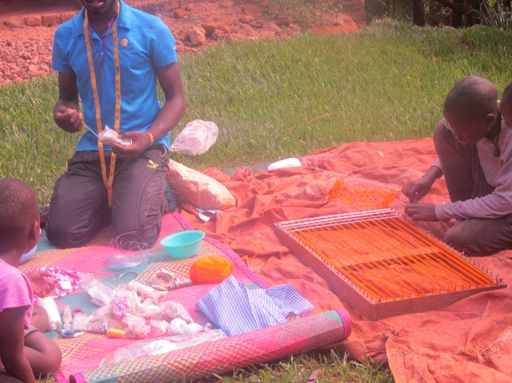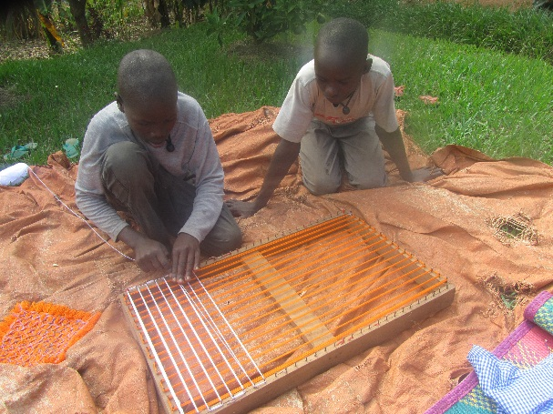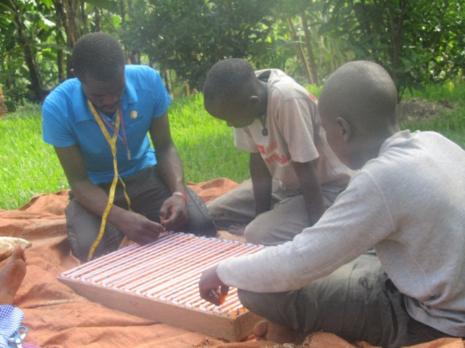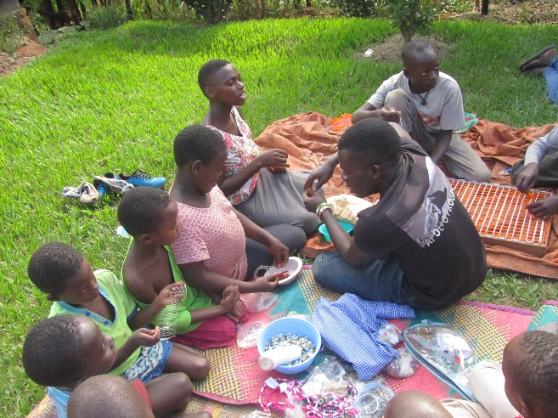
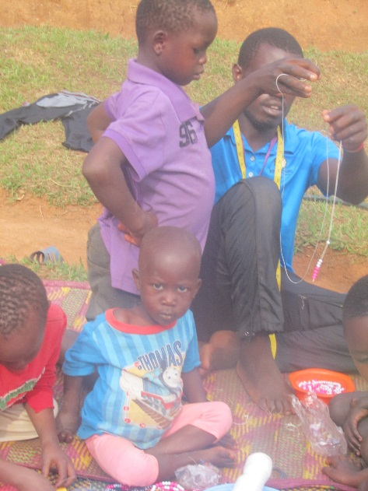

Hens of hope project.
Through this project Nakyeyune Walder and Kahindo Ryannah have received hens. This is to train our children how to work with their hands to earn an income for personal value,
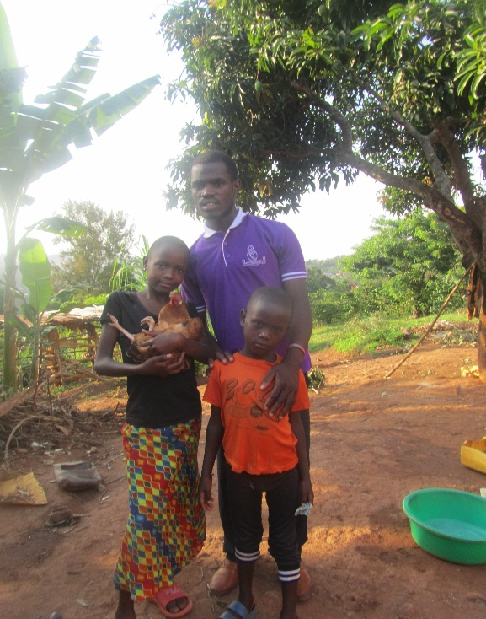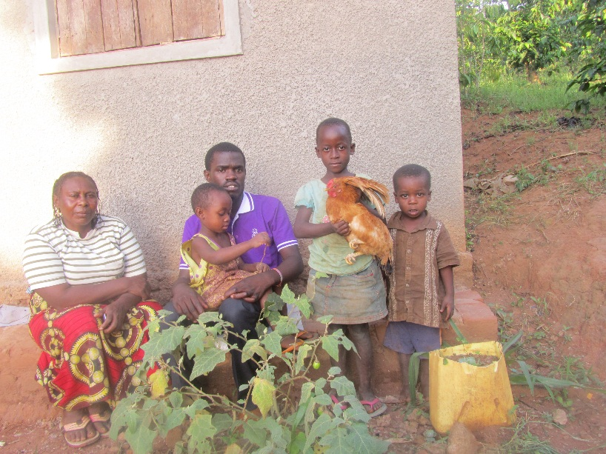
Nakyeyune walder with the hen. Kahindo Ryannah with the hen

HENS PROJECT FOLLOWUP.
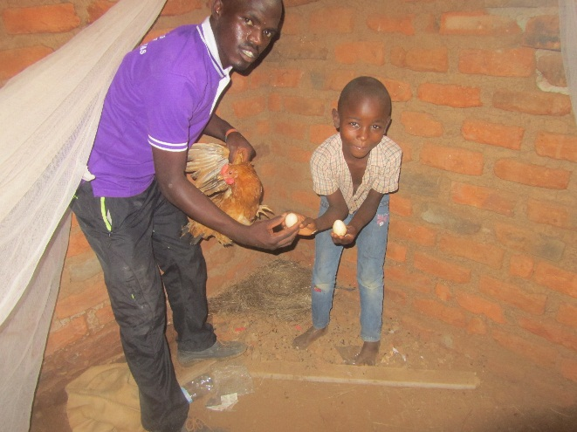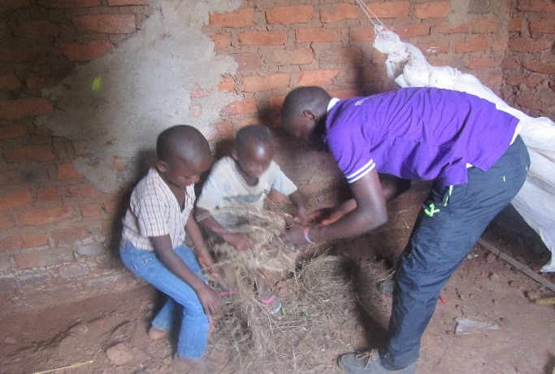
Period of laying eggs and training children how to make local laying area for the hens,
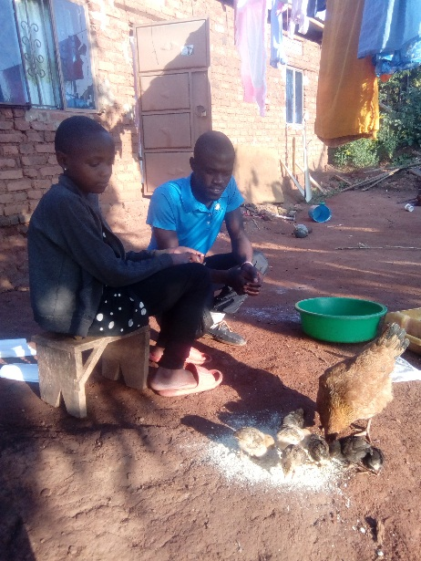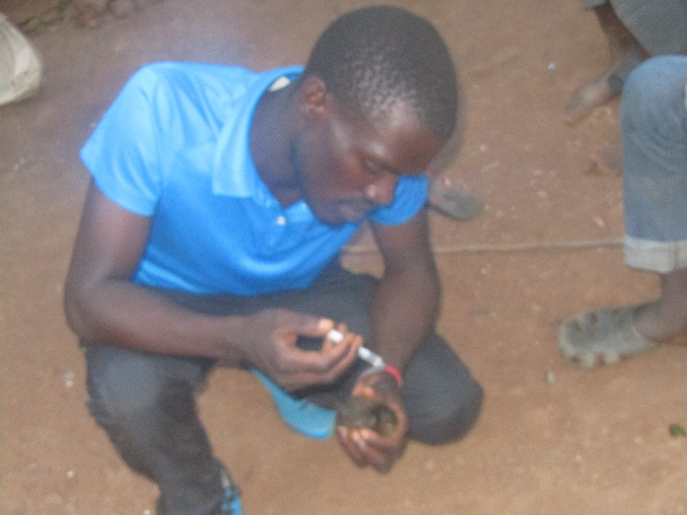
Making follow up and treating the hatched chicks.

SCHOOL VISITATIONS.
We have visited Bishop Ssenyonjo primary school in Lwengo district two times.
Books, pencils and pens are normally given out to the orphans in this school, these maybe total orphans or partial orphans.

- FIRST TIME VISIT.
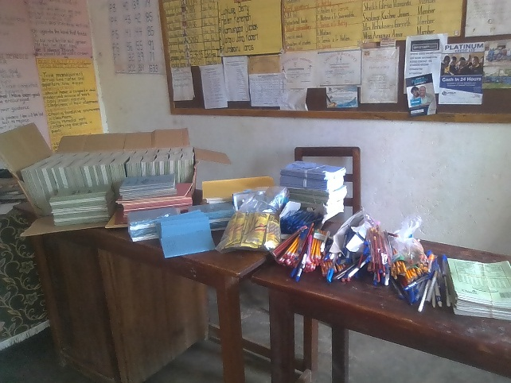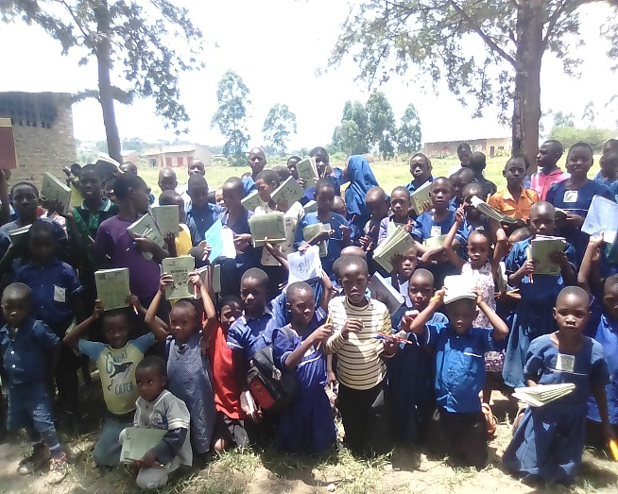
Books pens and pencils given out to children at Bishop Ssenyonjo primary School.

- SECOND TIME VISIT AT BISHOP SSENYONJO PRIMARY SCHOOL.
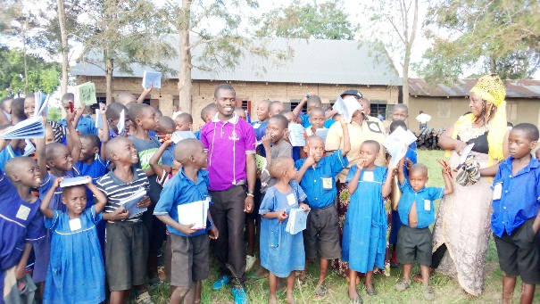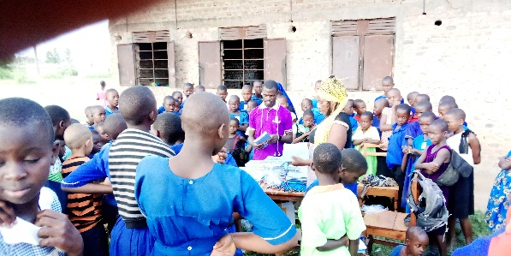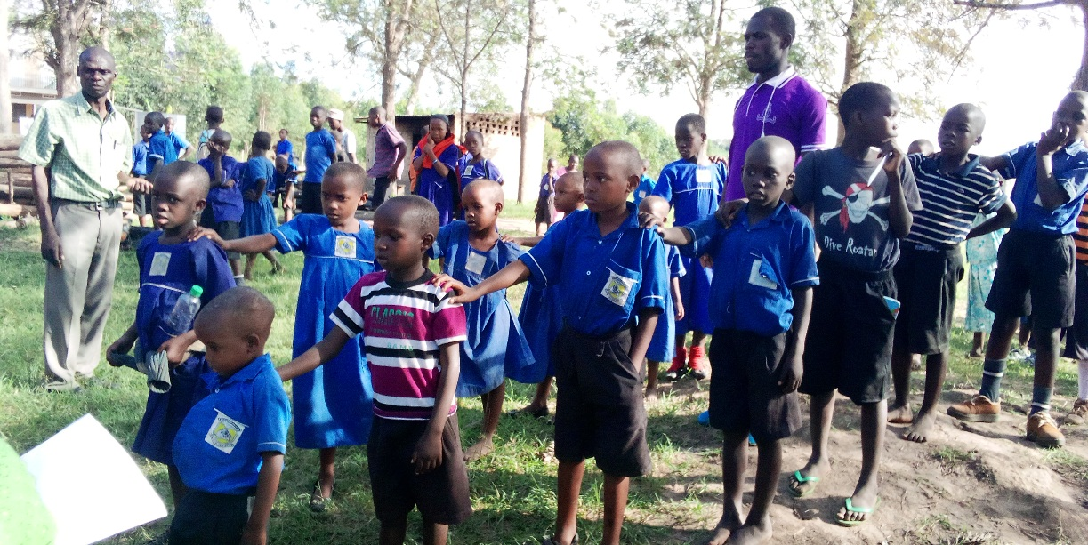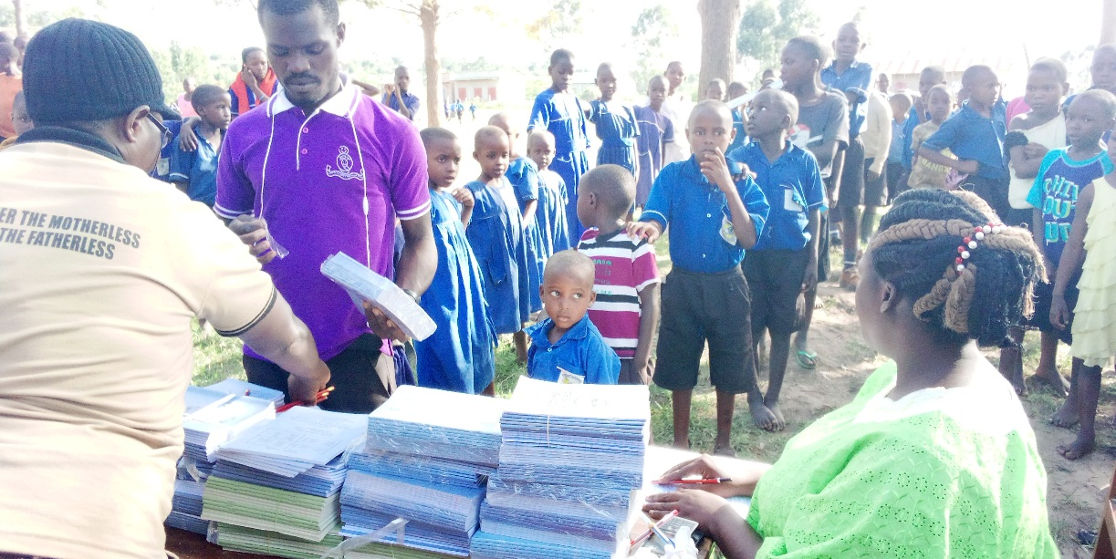
BOOKS PENS AND PENCILS GIVEN TO RESTORE HOPE TO CHILDREN IN THE SCHOOL

CHILDREN IN SSENYANGE RECEIVING SCHOOL REQUIREMENT.
During back to school time we give out school requirement to the needy children in the local community.
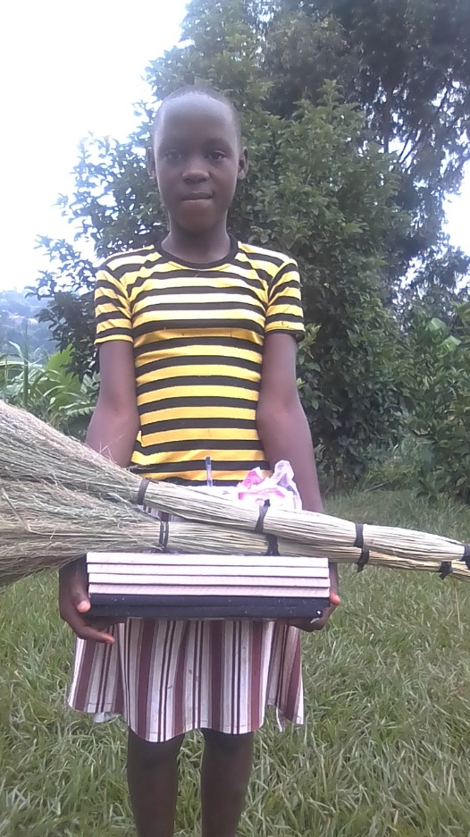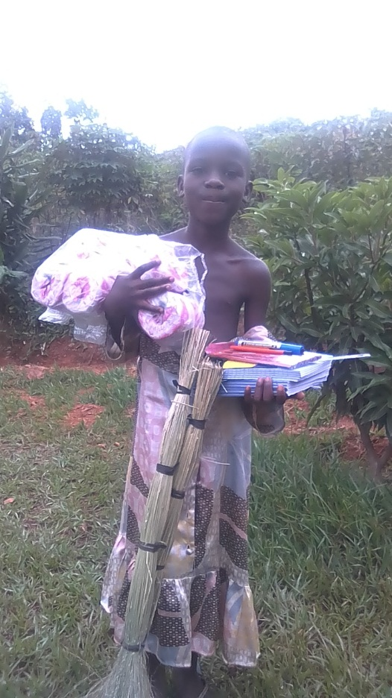
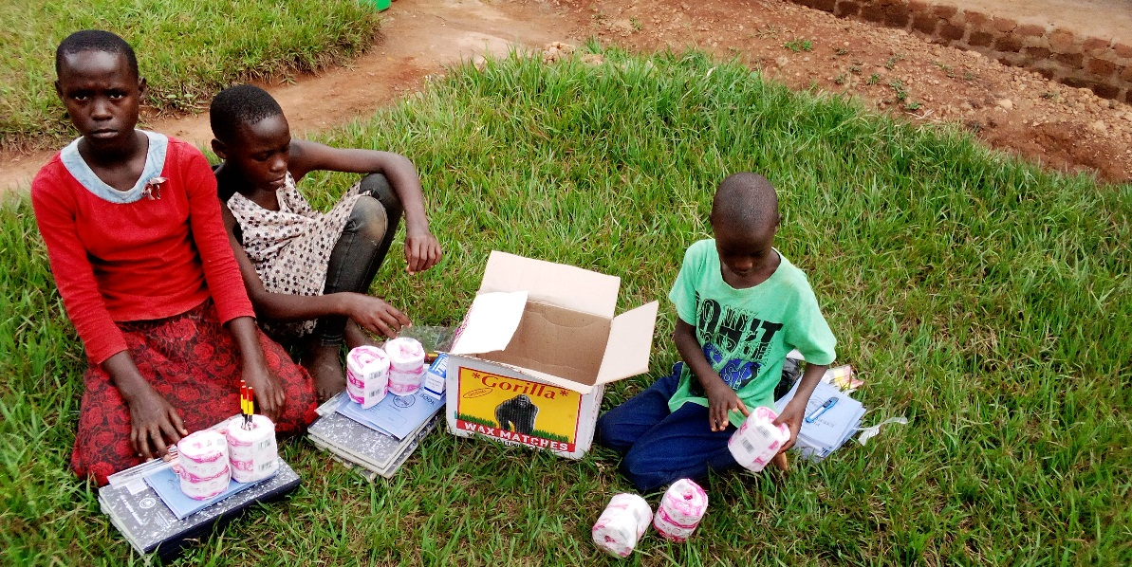

INTERESTING MOMENTS WITH CHILDREN IN THE COMMUNITY.

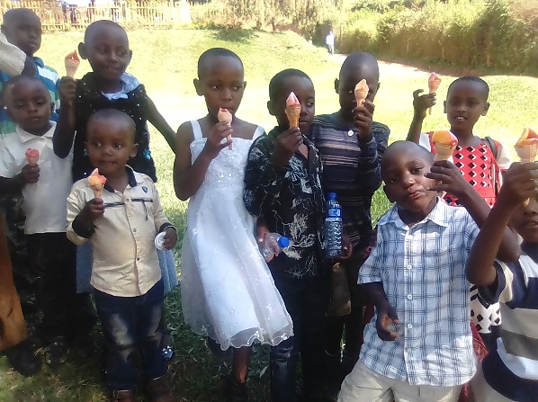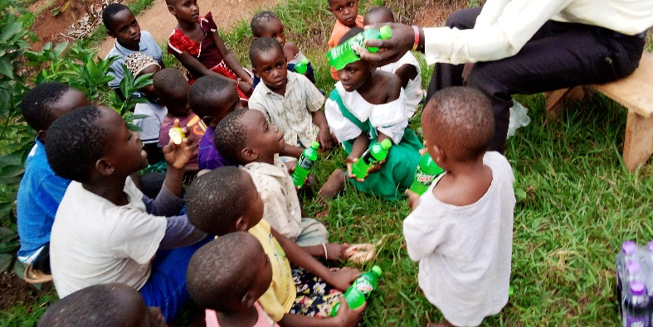

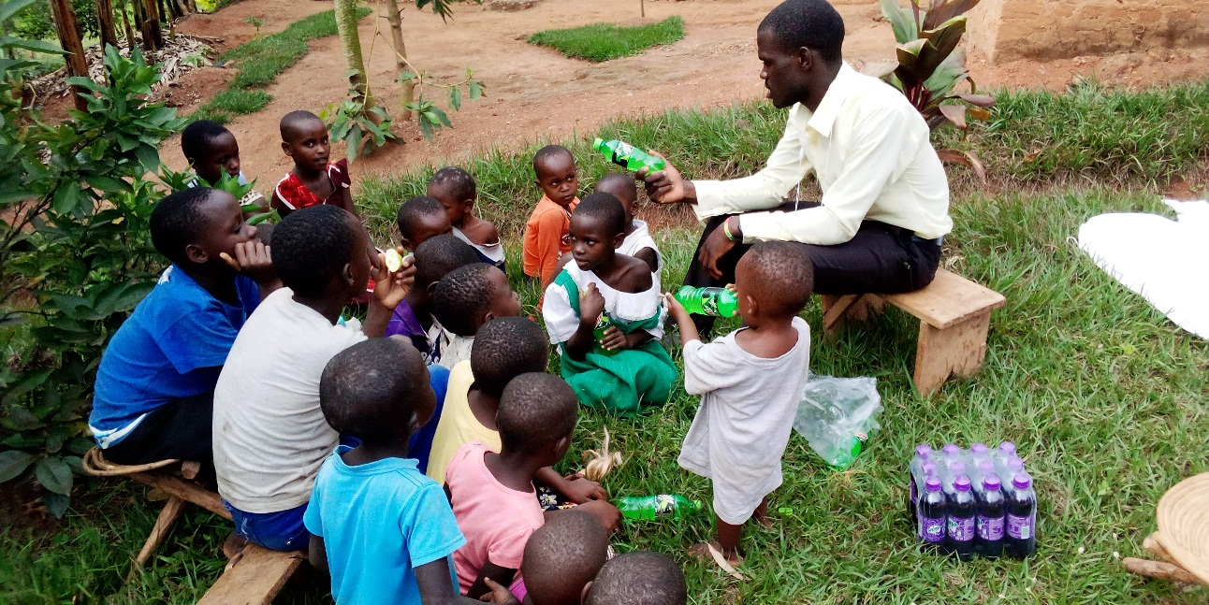
This is the time when we reach out to children to share with them about hope and feeding the hungry.

GIVING OUT DONATED ITEMS TO THE CHILDREN.
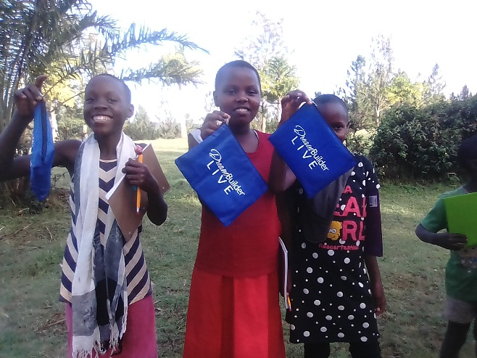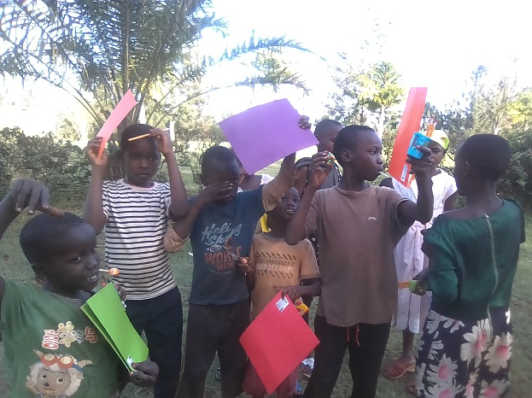
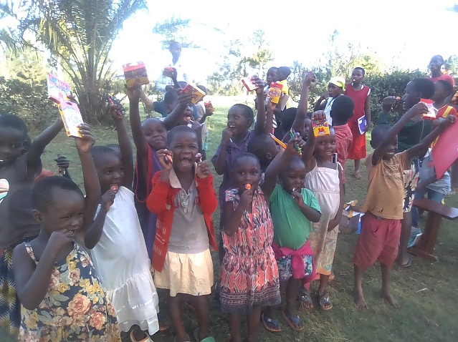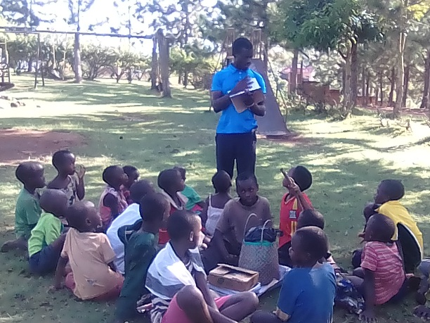
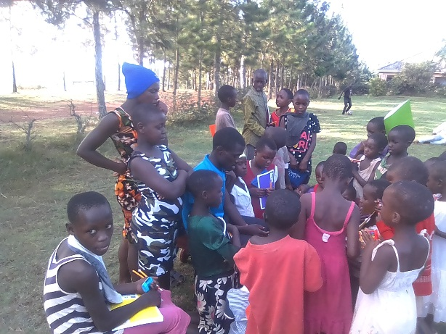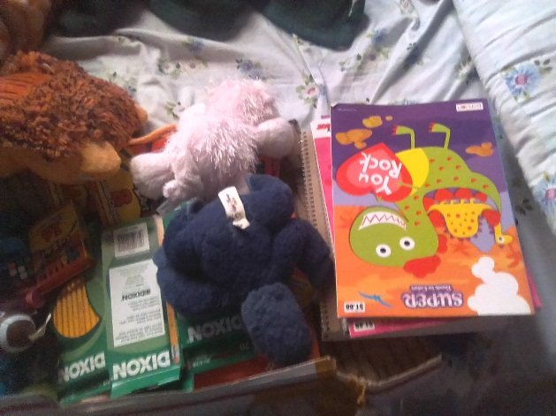
Our children recieves their donation, this was a donation from USA to the children in our community.
EASTER PARTY.
We for the last two easter days we have always had easter parties were we invite children in the community of bwala, ssenyange and kimaanya to share with them about the love of Jesus Christ and to introduce the hopeless children to hope. We take time to have fun time with the children through sports and singing
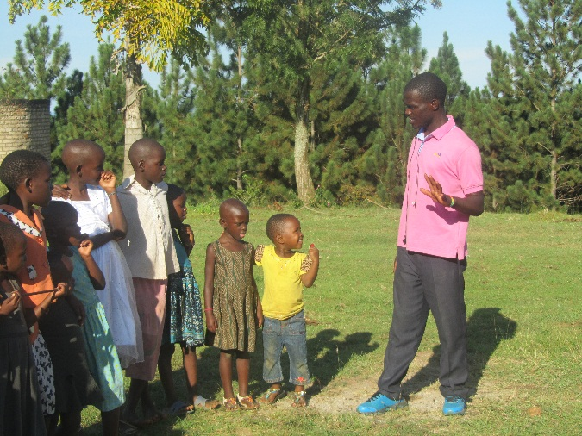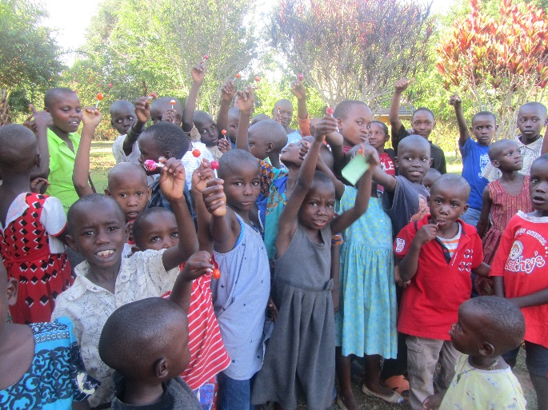
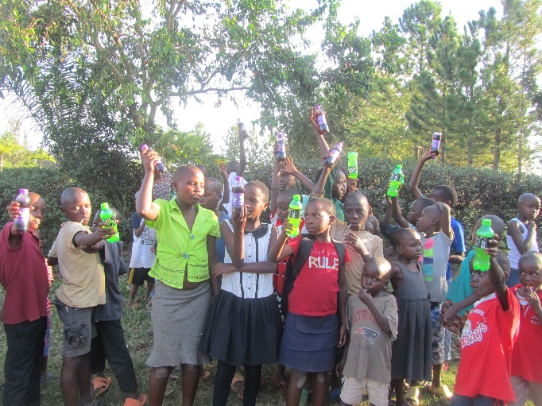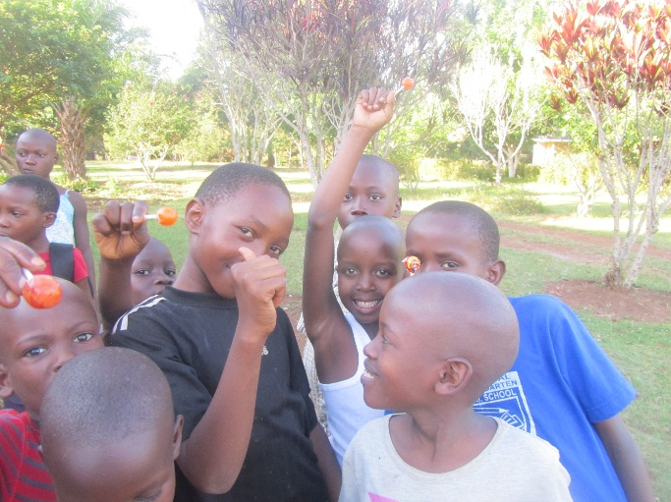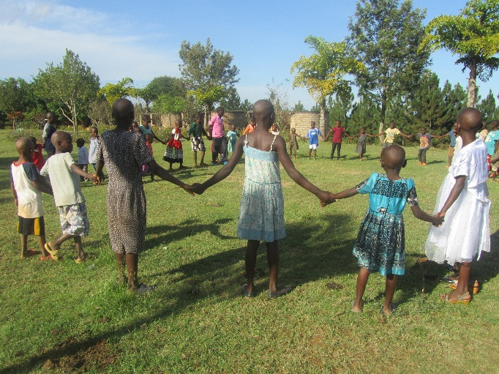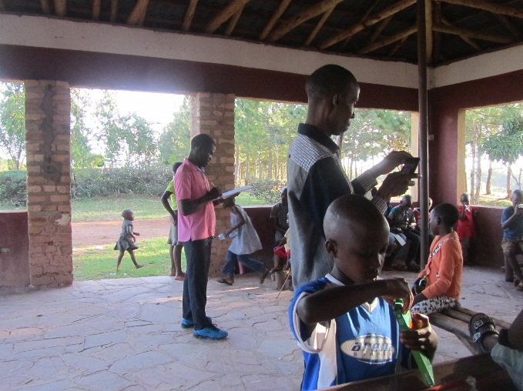
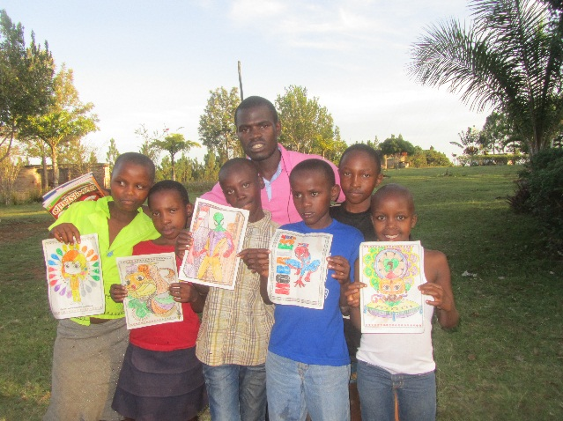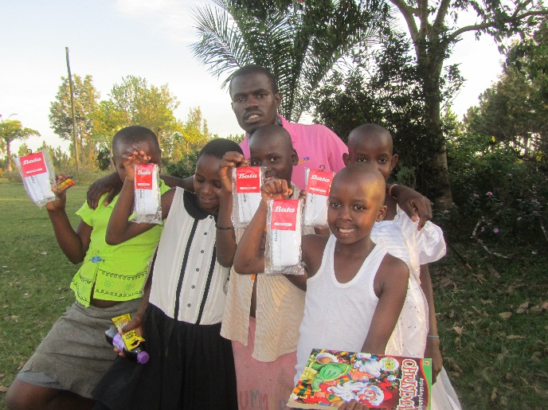

REACHING OUT TO COMMUNITY TO STOP CHILD ABUUSE AND TORTURE.
This a 12year old boy, called WASWA ALOUSOUS, that I found in kitengesa who was carring a termite hill(enkulukuku), of about 10kgs.
He is aboy I have made follow up over his life with heart for the love of money and he was asked by some one in the trading centre to get him this termite hill inorder to be given 1000/=, I found him carring this, which was very heavy even to me, so I decided to help him upto the place where he was taking it.
The main aim was to find out the truth of everything.
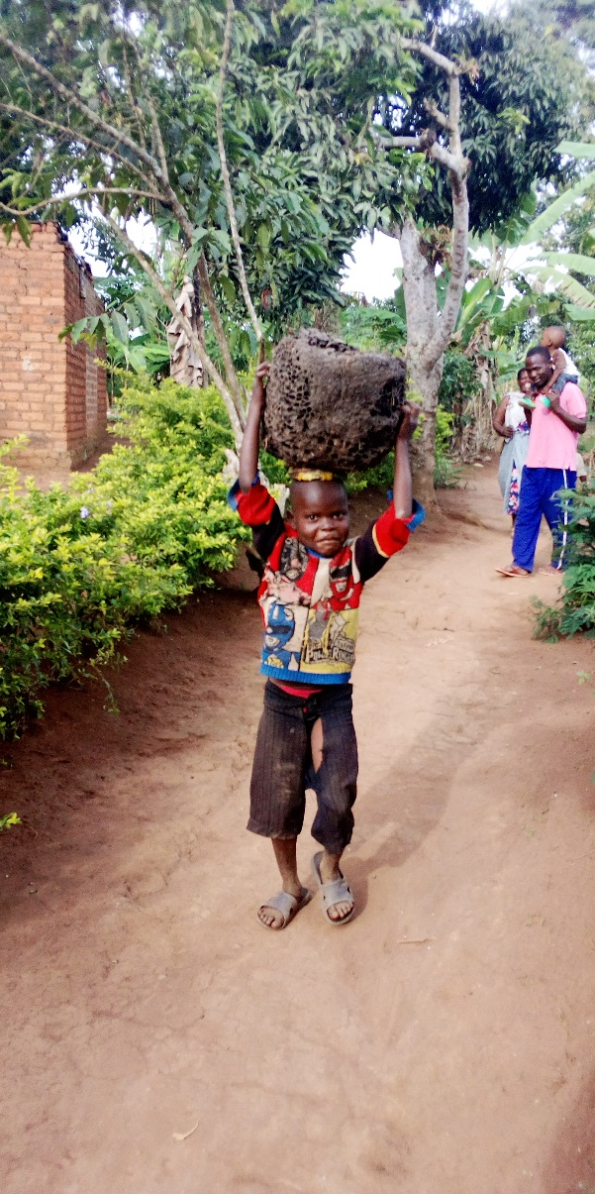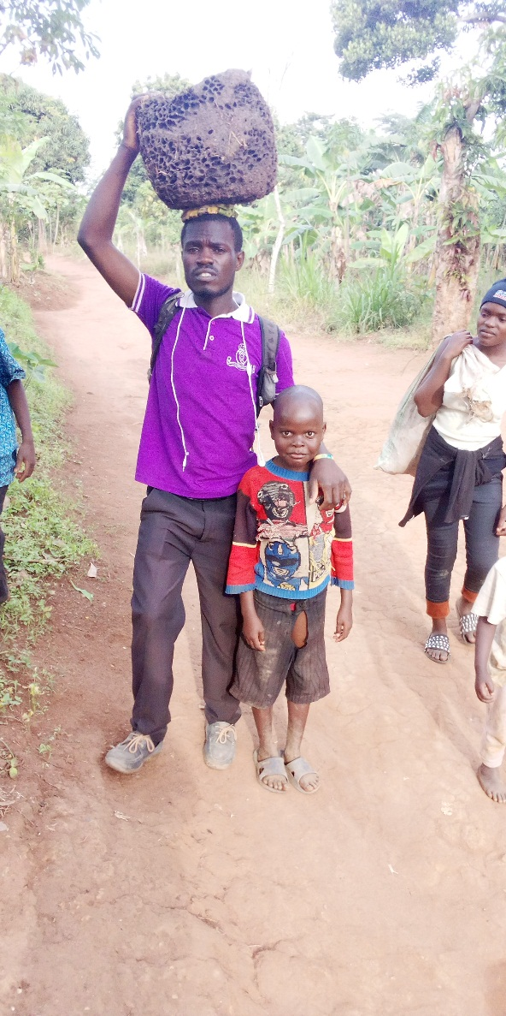

I decide to make a follow up. The boy was afraid and failed to show me the right people so he ended up taking to the wrong place where he took me to other people who didn’t expect him yet they seemed to know him.

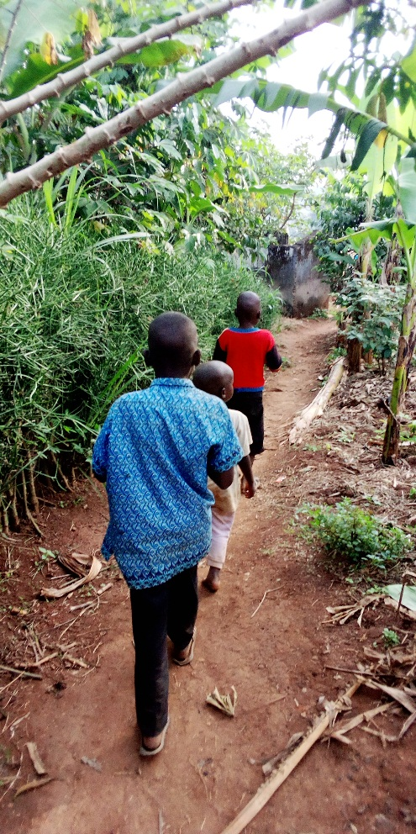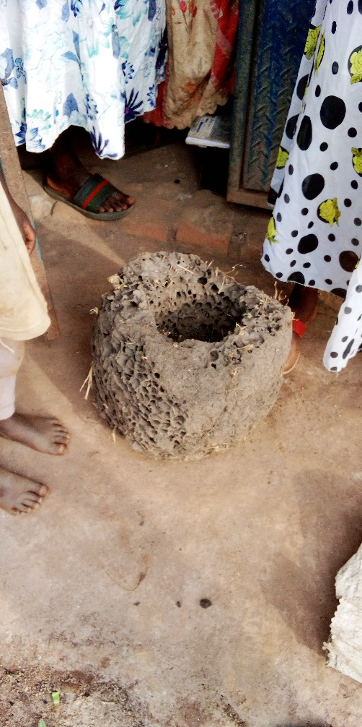
After one week I went to find the right parents of the boy, I started my investigations from the place where the boy took me, but to my surprise these people refused to direct me to the boy’s home. So I went back to the trading centre and I used my experience to find the boy by asking every child i met and showing them the boy’s photo until I found a young boy who told me that Waswa is his friend, he took me to the well where he had seen him going to fetch water. I found the boy sleeping besides the small road with this 2 litre 10 jerrycan. He was afraid to see me again after one week and he was in fear of taking me to his home place but the friend led me carring the jerry cans upto home with Waswa.
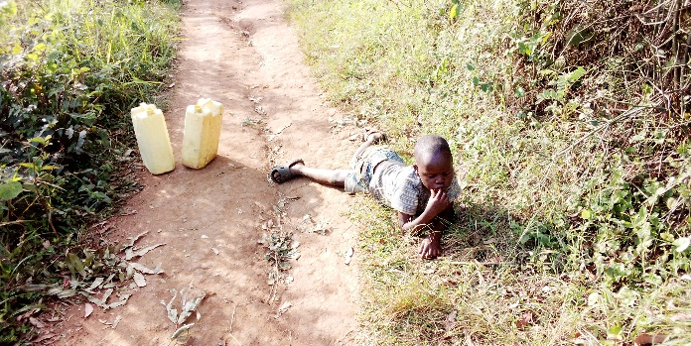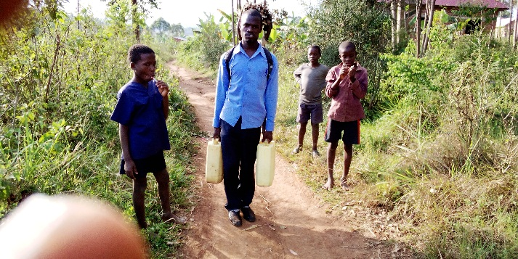
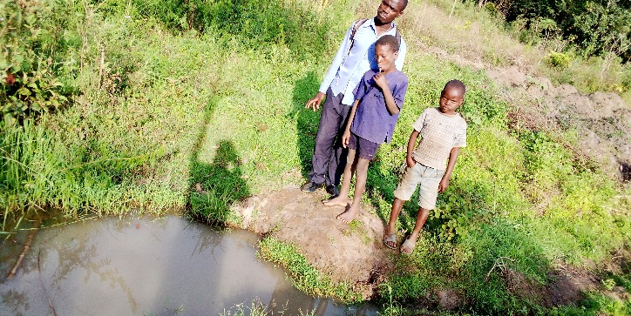
I was blessed i met Waswa’s mother, who is a single mother with 4 children. They live in asingle room, I was surprised to meet the lady who refused to direct me by saying she didn’t know where the boy stays trying to alert the mother just because she thought it was the police searching the mother.
I had time to take to the mother and I counselled her and taught her about child protection and development.
I blessed the family with; sugar, breads, and soap.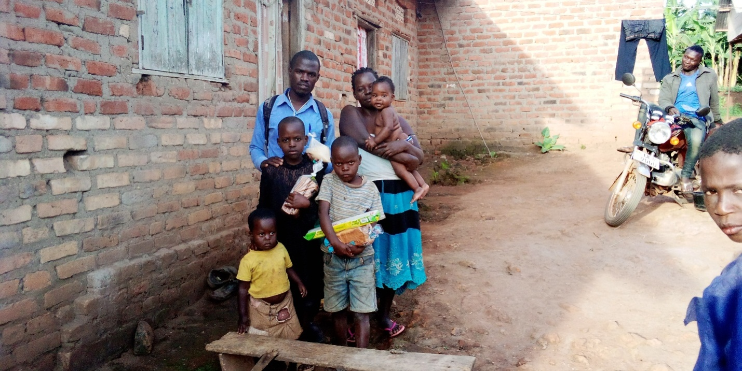

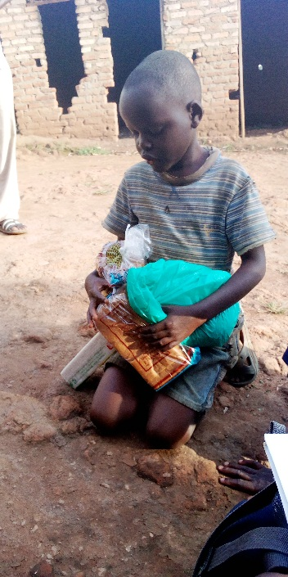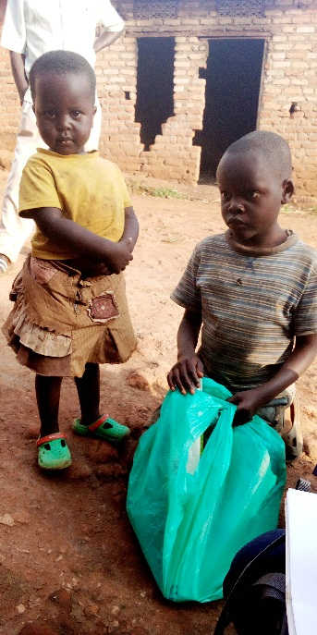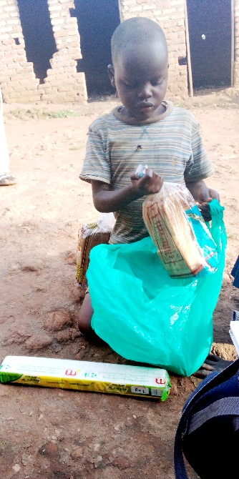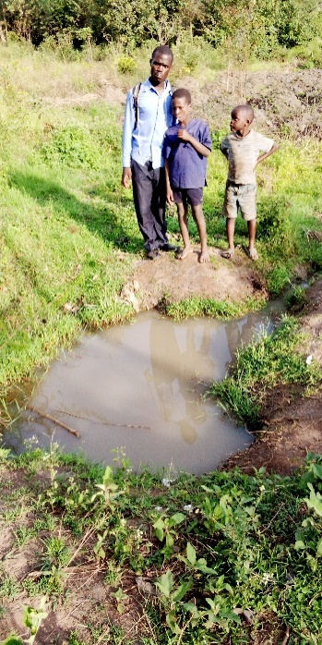 this family is still under follow up.

EDUCATION.
Currenty, we pay part of school fees to some of the ten children listed above to those whose age is ready to go to school. These children go to different schools. This partial school fees payment is due to liimited fund at a moment.

FINANCES.
Section a: Sources of revenue.
After registration we shall open up a bank account with three signatories from the board of directors.
The organization’s main source of funding shall be:
1. Funds sent from donor from different parts of the world.
2. Funds collected locally from organization projects for example poultry, and farming
3. Networking with other funding agencies. Any project funds shall be collected and banked on the project bank account.

FUTURE PLANS WITH VISION OF HOPE CHILDREN’S CENTRE.
- We hope to help children go for formal education/ vocational.
- We hope to help children gain hand craft skills through to skills project.
- We hope to fulfill all our objectives and goals as stated on the first two pages.

Reported by;
………………………………...
TAMALE ASHIRAF
vision bearer.
+256 779726269, +256 704544517

